Application : Demo Web Shop

**1.1 Objectives**

* To validate that the Application features are meeting the Customer Requirement
* To ensure a high-quality user experience with minimal bugs and security vulnerabilities.

**1.2 Scope**

The testing will include functional, non-functional, and security aspects of the application. The primary modules to be tested are:

* User Registration and Authentication
* Categorization and Search
* Ordering and Wish listing
* Invoice Generation

**2. Test Items/ Assumption**

The following components of the system will be tested:

* **Frontend**: UI components built with JQuery
* **Backend**: APIs and logic implemented using Node.js
* **Database**: PostgreSQL schema and data integrity
* **Hosting Environment**: AWS configurations

**3. Test Strategy/ Test Methodology**

**3.1 Testing Types**

1. **Functional Testing**: Verify that the system meets all functional requirements.
2. **Integration Testing**: Test interactions between different modules.
3. **Performance Testing**: Ensure the system performs well under load and stress.
4. **Security Testing**: Identify vulnerabilities and validate data protection mechanisms.
5. **Usability Testing**: Evaluate the user experience on desktop and mobile devices.
6. **Regression Testing**: Ensure that new changes do not affect existing functionality.

**3.2 Testing Levels**

1. **Unit Testing**: Developers will test individual components.
2. **System Testing**: The QA team will validate the complete system.
3. **Acceptance Testing**: Stakeholders will validate the system against the CRS.

**4. Environment Requirements/Test Environment**

**4.1 Hardware**

* Minimum of 8GB RAM and 4-core CPU for test environments.

**4.2 Software**

* **Browsers**: Chrome, Firefox, Edge
* **Testing Tools**: Selenium, Postman, JMeter, OWASP ZAP
* **Hosting**: AWS Test Environment

**5. Test Schedule/ Test Schedule**

| **Phase** | **Start Date**  **MM/DD/YY** | **End Date**  **MM/DD/YY** |
| --- | --- | --- |
| Test Planning | 01/08 /25 | 01/08/25 |
| Test Case Design | 01/08/25 | 01/10/25 |
| Test Environment Setup | 01/13/25 | 01/17/25 |
| Test Execution | 01/17/25 | 01/20/25 |
| Bug Fixing & Retesting | 01/21/25 | 01/21/25 |
| Final Acceptance Testing | 01/30/25 | 01/30/25 |

**6. Roles and Responsibilities**

| **Role** | **Responsibility** |
| --- | --- |
| Test Manager | Oversees the testing process and resources. |
| Test Lead | Coordinates the QA team and ensures adherence to the test plan. |
| QA Engineers | Design and execute test cases, report bugs. |
| Automation Engineers | Develop and maintain automated test scripts. |

**7. Risks and Mitigations**

| **Risk** | **Mitigation** |
| --- | --- |
| Delayed Development | Regular sync-ups with the development team. |
| Environment Issues | Set up backup test environments. |
| High Bug Count | Prioritize critical issues for resolution. |

**8. Approval**

| **Name** | **Role** | **Date** |
| --- | --- | --- |
| John Doe | Test Manager |  |
| Jane Smith | Product Owner |  |

**9.Deliverables:**

This section covers which all documents that has to be provided by the testing team at the end of test cycle.

Ex: Test cases, Traceability matrix, test execution report, defect report, release note, graphs & matrices.

Release Note: Along with the product, we release a note to the customer called as release note.

Release note consists of:

* List of open defects which are there in the product.
* List of bugs that are found in the previous release and fixed in the current release.
* List of pending bugs in previous release & fixed in current release
* List of features added, modified or removed in current release.
* Procedure to install the software.
* Version of the product.

**10.Graphs & matrices:**

Graphs:

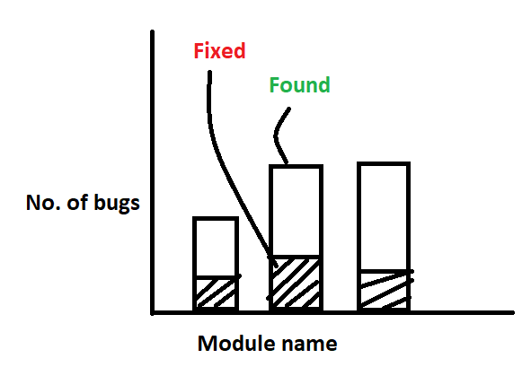

**Defect density (or) Defect distribution graph**

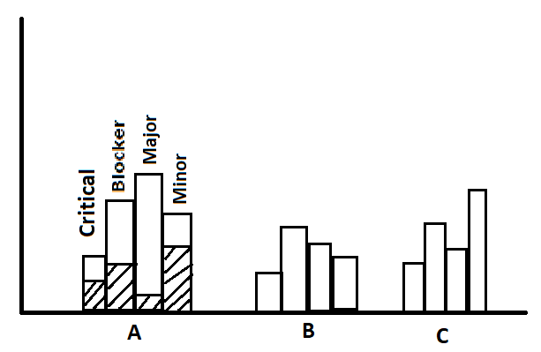

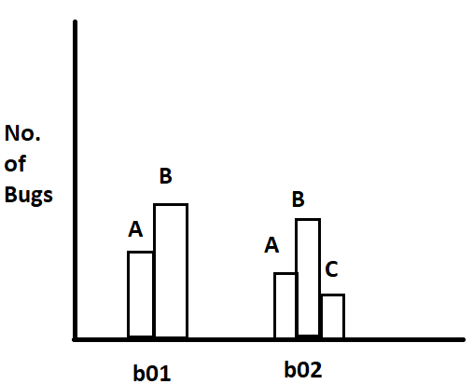

**Build-wise defect distribution graph**

Matrices:

Defect distribution matrices:

|  |  |  |  |  |  |  |  |
| --- | --- | --- | --- | --- | --- | --- | --- |
|  |  | **Critical** | | **Major** | | **Minor** | |
| **Sl no:** | **Module name** | **Found** | **Fixed** | **Found** | **Fixed** | **Found** | **Fixed** |
| 1. | Amount Transfer | 40 | 37 | 80 | 40 | 110 | 50 |
| 2. | Amount Balance | 80 | 70 | 150 | 80 | 200 | 120 |
| 3. | Transactions | 60 | 55 | 100 | 60 | 190 | 70 |

**11.Entry & Exit Criteria:**

**Entry criteria for system study:**

* Should have got approved requirement from customer
* Should have assigned engineers to do system study

**Exit criteria for system study:**

* Should have completed reading the requirement.
* Should have got answers for all the queries.
* All high and medium severity bugs are resolved.
* Functional coverage reaches 95%.
* Non-functional requirements (e.g., performance, security) are met.

**Prepare Test Plan:**

**Entry criteria for test plan:**

* Test plan template should be ready.
* Should have assigned someone to prepare test plan & review the test plan.
* Should have met the exit criteria of system study.

**Exit criteria for test plan:**

* Should have got approval for test plan.

**Write Test case:**

Entry criteria for writing test case:

* Test case template should be ready.
* Should have met exit criteria of test plan.
* Should have assigned the module to engineer.

Exit criteria for writing test case:

* Test case should be reviewed, approved & stored in repository.

1. **Test stop criteria:**

When will you stop testing?

* We stop testing when the product quality is very good or product quality is very bad.
* Product quality is very good means if all the end-to-end business scenarios are working fine.
* If there are no blocker or critical defects.
* There are few bugs left out which are all minor or major but are less than the acceptable limit set by the customer.
* If all the features requested by the customer are ready
* Product quality is bad means there are too many blocker & critical bugs.
* If it is crossing the budget.
* If it is crossing the schedule/deadline.

1. **Roles & responsibility:**

This section covers what each engineer should do in different stages of test life cycle.

Roles and responsibilities of Test manager:

* Write and review Test plan.
* Interact with testing team, development team, if needed with customer.
* Should handle all the issues and escalations.
* He should approve release note.

Roles and responsibilities of Test lead:

* Write and review Test Plan.
* Allocate work to each engineer and make sure that they are going to work and complete the task within the schedule.
* Consolidate all the reports which are sent by every TE and communicate with testing team, development team, project manager and customer.
* He conducts impact analysis meeting.

Roles and responsibilities of Test Engineer:

* Write Test case
* Review test case of another test engineer.
* Execute test case for his allocated features.

1. **Templates:**

This section covers formats for all the documents that we are planning to prepare in the entire test life cycle.

1. Test case template
2. Traceability matrix template
3. Defect report template
4. Test case review template
5. Test execution report template